**Docker Command Cheat Sheet**

* Create and run container: alpine image (Mini basit Linux Isletim sistemi)
  + *docker container run alpine*
  + *docker container run python:3*
* Parameter can use after docker container or docker container run
  + *docker container*
  + *docker container run –help*
* Create python image container name is proje1
  + *docker container run --name proje1 python:2*
* List of container
* *docker container ls (0nly working container)*
* *docker container ls -a*
* *docker container ls -a -q (Only list the id of container)*
* Get information about container
* *docker info*
* Start-Stop-Pause-Delete Container

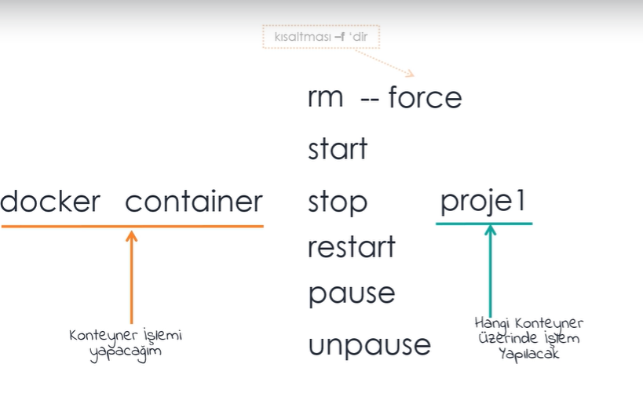

* Downlading Docker webpage to my local
* *docker container run -d -p 4000:4000 docs/docker.github.io*
* Rename the docker container; juliane to dockerweb
* *docker container rename juliane dockerweb*
* Delete Stopped Container:
* *docker container rm (name or id container)*
* *docker container rm --f (name) -delete running container also*
* Delete all the container in one line:
* *docker container rm $(docker container ls -a -q)*
* Delete Stopped Container -best practise-
* *docker container prune*

**Nginx//Windows IIS**

**host container micrsoft/iis**

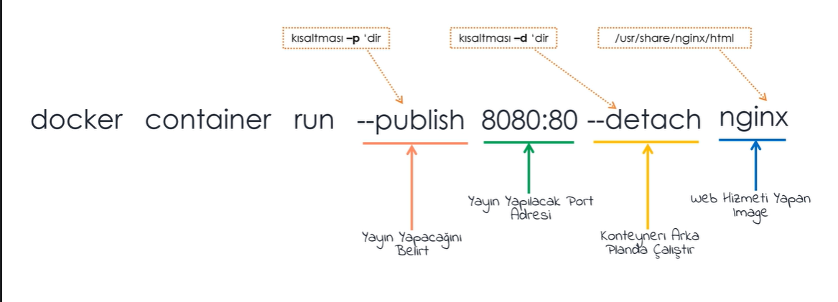

Run the website by Nginx

* *docker container run -p 8080:80 -d nginx*

*8081:80 possible but 8080:81 not possible*

p: We determine the port

P: Automatically random port determine

* Create nginx container with the name of myweb and port determine ramdomly, it will run backround the console

*docker container run -P -d --name myweb nginx*

**Connect & Work on Container without SSH Connection**

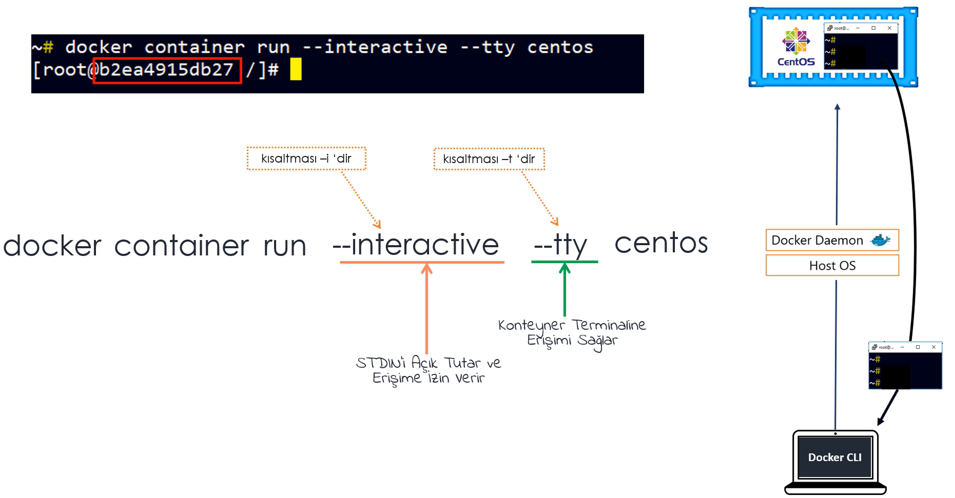

* We can reach the terminal of nginx or python on container.
* *docker container run -i -t nginx bash*
* *docker container run -i -t python:3 python*
* Create docker container of alpine with the name of Op.Sys1 and terminal of alpine(mini linux) is sh
* *docker container run -it –name OpSys1 alpine sh*
* *docker container run -it python:3 bash*

*/# python -V (give us version )*

*/# python (open the terminal for python code)*

* Delete the container after working on the terminal
* *docker container run --rm -it python:3*
* *We can reach the Linux desktop by container (actually it is just image created by someone)*
* *docker container run -p 6080:80 -d dorowu/ubuntu-desktop-lxde-vnc*
* If we want to work on any “working container” created before.

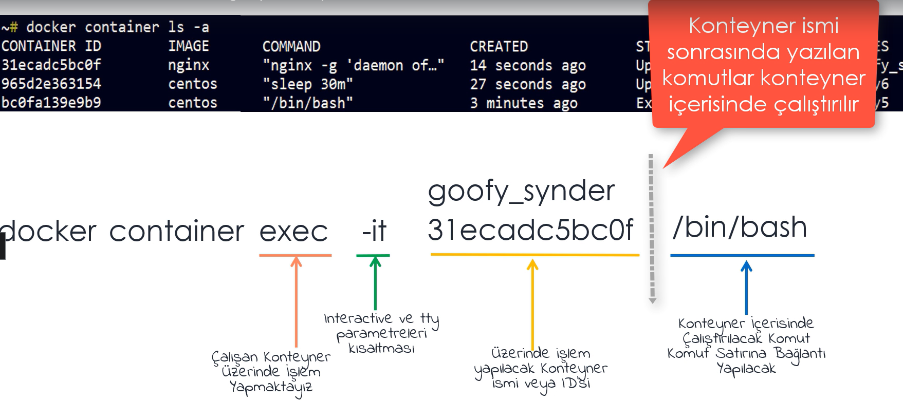

* To run the command inside of any working container
* *docker container exec linuxcontainer(name/id) yum install -y vim*
* Created centoscontainer and second command create folder with/withoput entering centos terminal
* *docker container run -d --name centoscontainer centos sleep 30m*
* *docker container exec -it centoscontainer bash*

*# mkdir app1*

* *docker container exec -it centoscontainer mkdir app2*
* Installing nginx on the centoscontainer created
* *docker container exec centoscontainer yum install -y nginx*
* Create script file inside container to be able to install or run packet from outside the container.
* *~#docker container exec -it centoscontainer bash*

*]# cd tmp*

*]# echo “ *

*> yum -y update && *

*> yum install -y vim && *

*> mkdir app3 && *

*> touch app3/list.txt “ >>script*

*]#chmod 755*

*]#exit*

*~# docker container exec -it centoscontainer /bin/bash ./tmp/script*